Ride & Stride for Sarcoma!
Fundraising Kit

Contact us:

T 08 9427 1744 The Abbie Basson Sarcoma Foundation Ltd
e: events@sockittosarcoma.org.au PO Box 8271, Perth Business Centre
w. www.sockittosarcoma.org.au Perth, WA, 6849

Contents

Thank You 2

Fundraising Ideas 3

Fundraising checklist 4

The Day of Your Event 5

How we can help you 6

Merchandise 7

Legal Responsibilities / terms & conditions 8

Thank You

A BIG thank you for getting involved with the Ride & Stride for Sarcoma! Your support means a great deal to us.

By fundraising for Sock it to Sarcoma! you will be helping us provide FUNDING FOR RESEARCH into this rare and aggressive bone and soft tissue tumours that attract less than 1% of the cancer research dollar.

You will also be helping us by raising AWARENESS, making people aware of sarcomas and the signs to look for. Unfortunately, 2 out of every 5 people diagnosed with a sarcoma do not survive 5 years post-diagnosis, but the good news is that if it is diagnosed early enough and treated quickly by the right specialists then the chance of a person’s treatment leading to a cure is greatly increased
.
We rely on the support of people like you for our fundraising.

So, again

THANK YOU.
~

Fundraising Ideas

This Fundraising Kit has been developed to help guide you through planning a successful fundraising event and here are a few ideas to inspire you:

Odd / Crazy Sock Day: For a gold coin donation you could allow your child’s school pupils and teachers Or your work colleagues to wear odd or crazy socks for the day.

Morning or Afternoon Tea: This can be a small event at home with friends
& family, at work with other colleagues or a larger affair at a community hall or even at a hotel where they will take care of the catering for you.

A personal challenge: Obtain sponsorship from people to do a personal challenge ie: Hair Dye/ Shave, weight loss, chocolate free month, whatever you can think of !

Car Wash, Mow Lawns, other odd jobs: Offer to wash your family/friends or neighbour’s cars or mow lawns or do other odd jobs for them.

Movie Night - Girls/Blokes night in: Instead of going out one night ask you friends and family to donate the money that they would spend on a ‘usual night out’ and have everyone around a make an ‘unusual night in’!

Donations in lieu of gifts: Instead of having gifts for your birthday/anniversary, Christmas etc ask people to donate the money they would spend to Sock it to Sarcoma!!

Garage Sale: Clear out your cupboards, store rooms and garage, get your family and friends to do the same and hold a garage sale.

Quiz Night / 60’s Night / Motown: Hold a quiz or music night at your local community or sporting centre

Raffle: Contact local businesses or people you know to obtain items, make up a basket/box, take a photo, put the word out, get posters up and sell tickets. Limit the time until the draw to perhaps 1 month.

Dinner & Auction – Organise a dinner with friends, family, colleagues and include an auction to raise more funds, seek out local businesses who may be interested in donating items.

Attend our annual Gala Dinner – Every year Sock it to Sarcoma! holds a Gala Dinner in November, get together with family and friends and make up a table of 10 it could be as easy as that!

Workplace Matched Giving. – check to see if your workplace will match the amount of funds you raise

Fundraising Checklist:

1: Planning your event:

- Get people to help you, organise a committee to spread the workload as organising an event on your own can be quite stressful.
- Set a financial goal
- Choose a date (be mindful of public & school holidays)
- Choose a venue or location
- Create a budget
- Check if any licenses or permits are needed for your event (eg liquor licences or raffle permits)

2: Venue or Location

    - Think about how many people may attend or take part in your event
    - If outdoors, think about the possible weather conditions (shelter/shade)
    - Negotiate prices as some venues will reduce their prices for charity events
    - Plan food & beverages (if applicable)
    - Plan any audio visual arrangements (if applicable)
    - Decide on a room/area set up
    - Confirm set up times and an agenda

3: Promotion & Support
- Be clear in communicating why you are supporting Sock it to Sarcoma!
- Prepare flyers to promote you event to go into local business windows, hand out around your workplace, school or shopping centre notice boards
- Use Email to contact people you, your friends & family know
- Set up a Facebook event or Twitter
- Contact local and known businesses for givaways/raffle/auction items
- If you are using a venue ie hotel ask if they will promote your event through their database
- Contact local media (newspapers/TV/Radio
- Use the Everyday Hero or MyCause page (see below)
- Inform people that they can make a donation through the Ride & Stride for Sarcoma! website if they are unable to attend your event but wish to donate.
- Order your SitS promotional items (ribbons, wrist bands, key rings, t-shirts, caps sweatshirts etc) to sell at your event.

5: The day of your Event:

BE ORGANISED!!!!

- Bring receipt books, raffle tickets, boxes to collect raffle tickets, a float of coins/notes
- A box or tin with a lid to keep any money collected (Make sure you have a safe place to keep it throughout your event)
Most importantly HAVE FUN !!!

6: After your event:

- Send out thank you emails/letters to those that have supported your letting them know how much you have raised. People are very appreciative of feedback from events that they have supported.

- Return any unused promotional items to Sock it to Sarcoma!!

How Sock it to Sarcoma! can help you

- Answer any queries you have regarding your event and offer advice and encouragement.

- Attend your event to represent Sock it to Sarcoma! (subject to availability)

- Provide a letter of support to validate the authenticity of your event

- Provide a ‘Proudly Supporting Sock it to Sarcoma!’ logo for your use when promoting your event

- Provide the following templates to assist you:

- Donor or supporter thank you template
- Certificates of appreciation (for large donors)

The template is a guide only and you can tailor the content to suit your needs. The Sock it to Sarcoma! logo can only be used for approved purposes and should remain untouched and unaltered.

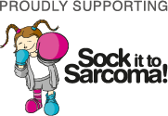

Merchandise

Some of the items we have available:
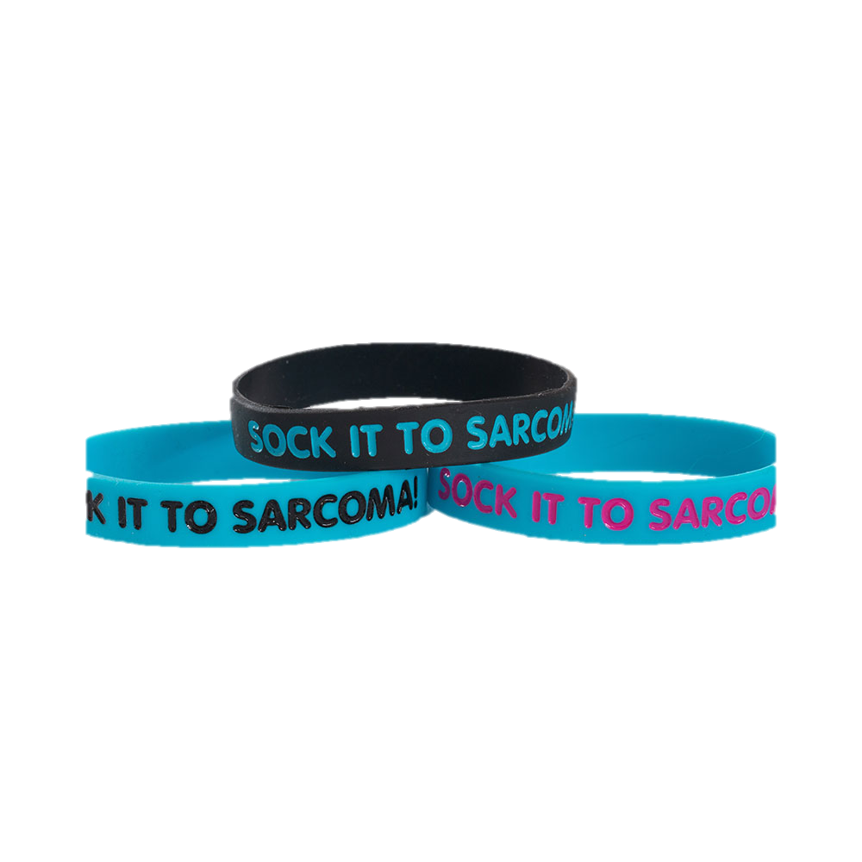
Awareness ribbons
Wrist Bands
Key Rings
Bumper Stickers
Window Decals
T Shirts
Polo shirts
Singlets
Caps
Hoodies
Socks

Legal Responsibilities / terms & conditions

Permits and Licenses:

When fundraising for Sock it to Sarcoma!, it is your responsibility to check if any permits or licences are needed for your fundraiser; to apply for these and to make sure you comply with any terms and conditions.

Logo

Our logo must only be used once approval for its use has been given.
It must be used in accordance with the permissions granted and without changes to the format.

Tax deductible receipts

Tax deductible receipts may be issued through the Foundation only for donations of $2 and above made to Sock it to Sarcoma! Merchandise, food and drink, tickets and other purchases where goods or services are received for a monetary exchange are not eligible for a tax-deductible receipt. If someone wishes to receive a tax deductible receipt for a donation to the Foundation via your fundraiser, please contact us at admin@sockittosarcoma.org.au to discuss how this may be handled.

